**Software Requirement Specification**

For

**SUST Online Community(SOC)**

**Version:1.0**

**Project Submitted by:**

Gourab Saha(2017831004)

Fazle Rabbi Rakib(2017831030)

Mehedi Hasan(2017831040)

**Project Submitted to:**

Sayma Sultana Chowdhury

Assistant Professor

IICT,SUST

Table of Content

**1.Introduction** **2**

1.1 Purpose 2

1.2 Document Convention 2

1.3 Reading Suggestion 2

1.4 Project Scope 3

1.5 References 3

**2.Overall Description** **4**

2.1 Product Perspective 4

2.2 Product Features 4

2.3 User Classes & Characteristics 5

2.4 Operating Environment 7

2.5 Hardware Requirement 8

2.6 Design and Implementation Constraints 8

**3. External Interface Requirements** **9**

3.1 User Interface : 10

3.2 Hardware Interface: 11

3.3 Software Interface : 11

3.4 Communication Interface : 12

**4.System Features** **12**

Figure (4.1.1) : Feature Requirements 12

Figure (4.1.2) : Activity Diagram of Login & Create Acc. 14

Figure (4.1.3) : ER Diagram of student & system 15

Figure (4.1.4) : ER Diagram of CR and System 16

Figure (4.1.5) : ER Diagram Teacher & System 17

Figure (4.1.6) : ER Diagram Alumni & System 18

Figure (4.1.7) : Activity Diagram of Posting 19

Figure (4.1.8) : Use Case Diagram. 20

**5.Other Nonfunctional Requirements** 20

5.1 Performance Requirements 20

5.2 Safety Requirements 20

5.3 Security Requirements 21

5.4 Software Quality Attributes 21

# 1.Introduction

## 1.1 Purpose

To build a online community of SUST **(SOC),**providing all academic,co-curricular and current activities information of SUST for all Sustians.

## 1.2 Document Convention

* **SOC :** SUST Online Community.
* **Authentication :** Verified users by administrator.
* **CR :** Class Representative.
* **User :** Teachers and Students.
* **SRS :** Software Requirement Specification
* **UML:** Unified Modeling Language
* **ER:** Entity Relationship Diagram
* **DFD:** Data flow Diagram

## 1.3 Reading Suggestion

This is a prototype for an online based system that will serve all needed information about SUST to all Sustians. Some recommended topic for readers:

● **Developers:** Product feature, User characteristics,

Operating environment, System features.

● **Designers:** Project scope, User characteristics, System

features, External interface requirements.

● **Domain:** Product perspective, Product features, User

characteristics, System features,

● **Students/Public:** Project scope, Product features, System features.

## 1.4 Project Scope

Goal of **SOC** is to access all necessary informations of SUST more easily and precisely to it’s users. **SOC** is an online based system, based on relational database and the data shared by it’s users.

## 1.5 References

For more information visit-

**●**[**https://sust.edu/iict**](https://sust.edu/iict) **●**[**https://en.wikipedia.org/wiki/Software_requirements_specification**](https://en.wikipedia.org/wiki/Software_requirements_specification)

Survey Link:

**●**[**https://docs.google.com/forms/d/1iqMlcL2HoggSgvhxzTu2Zy94FSgZVmEHMpQXwrTMqGM/viewform?fbclid=IwAR1EM38TX2udch9HuLmyRFVaovTU-cIImGsJiQO_gK0N-M9pHRCiqwWTrb0&edit_requested=true#responses**](https://docs.google.com/forms/d/1iqMlcL2HoggSgvhxzTu2Zy94FSgZVmEHMpQXwrTMqGM/viewform?fbclid=IwAR1EM38TX2udch9HuLmyRFVaovTU-cIImGsJiQO_gK0N-M9pHRCiqwWTrb0&edit_requested=true#responses)

# 

# 

# 2.Overall Description

## 2.1 Product Perspective

**SUST Online Community** is a new online based system for providing information and facilities for all Sustian:

* **Newsfeed: SOC** will provide a newsfeed with all latest news related to academic,co-curricular and current activities of SUST.
* **Information:** Store all needed information about teachers,current students, academic calender,alumni and organizations.
* **Share and Feedback:** **SOC** is a social based online application,so user can share news or information and also can give feedbacks.

## 2.2 Product Features

**SUST Online Community (SOC)** will provide:

* **Basic Information of Student**
* Name
* Department Name
* Blood Group
* Registration No
* Email and Contacts
* Address
* **Basic Information of Teacher**
  + Name
  + Department Name
  + Qualifications
  + Achievements
  + Email and Contacts
  + Blood Group
* **Basic Information of Alumni**
  + Name
  + Department
  + Batch
  + Current Status
  + Email and Contacts
  + Blood Group
* **News Feed**

**1. All SUSTian News**

1.1 Daily Affairs

* + Academic News
  + Cultural Events
  + Organizational News
  + Festivals

1.2 Emergency Post

* + Blood Related
  + Fire Related
  + Erratic Situation

**2. Departmental News**

* + Daily Class Updates
  + Exam Dates
  + Exam Results
  + Departmental Activities

## 2.3 User Classes & Characteristics

|  |  |
| --- | --- |
| **Super Admin** | * Add,delete Admin * Suspend user * Activate user * Create user privilege * Assign user to a privilege * Update Profile |
| **Admin** | **1.System Manage:**   * Add,delete user * Approve CR request * Suspend user * Activate user * Create user prIvilege * Assign user to a privilege * Update Profile   **2.Dashboard Manage:**   * Approve post * Delete offensive post * Response to reports * Delete offensive Comment |
| **CR** | * Create Profile * Edit Profile * Request to be CR * Post * Share a post * edit,delete his post * Create Departmental Group   **2.In Departmental Group:**   * Add,suspend group member * Post Class Update * Post result * Approve post of group members * Suspend Offensive Posts * Suspend offensive comment * Share,edit,delete a post * Rating a post * Comment on a post |
| **Student** | * Create Profile * Edit Profile * Post * Share a post * edit,delete his post * Rating a post * Comment on a post |
| **Teacher** | * Create Profile * Edit Profile * Post * Share a post * edit,delete his post * Rating a post * Comment on a post |
| **Alumni** | * Create Profile * Edit Profile * Post * Share a post * edit,delete his post * Rating a post * Comment on a post |

## 2.4 Operating Environment

**• Operating System:** Windows, Linux , macOS, iOS and Android.

**• Database:** Oracle Database and Google Cloud.

**• Platform:** Java, Python, Net framework, PHP, JavaScript.

## 2.5 Hardware Requirement

* Android version 4.4 KITKAT (minimum, android user’s)
* 2GB ram
* 1.2 GHz processor
* Intel i5Q 2400
* Windows 7/8/8.1/10

## 2.6 Design and Implementation Constraints

This system will provide most of all necessary information about teachers,current students,alumni.**SOC** also will provide all latest news related to SUST which requires efficient data processing and manage- ment.No offensive or sensitive activities will be added in services of the system.

# 

# 

# 

# 

# 

# 3. External Interface Requirements

We put on a survey in SUST to gather requirements to make our system elegant and more user friendly.Here are some of them:

Figure : 3.0.1 Daily Usage of Social apps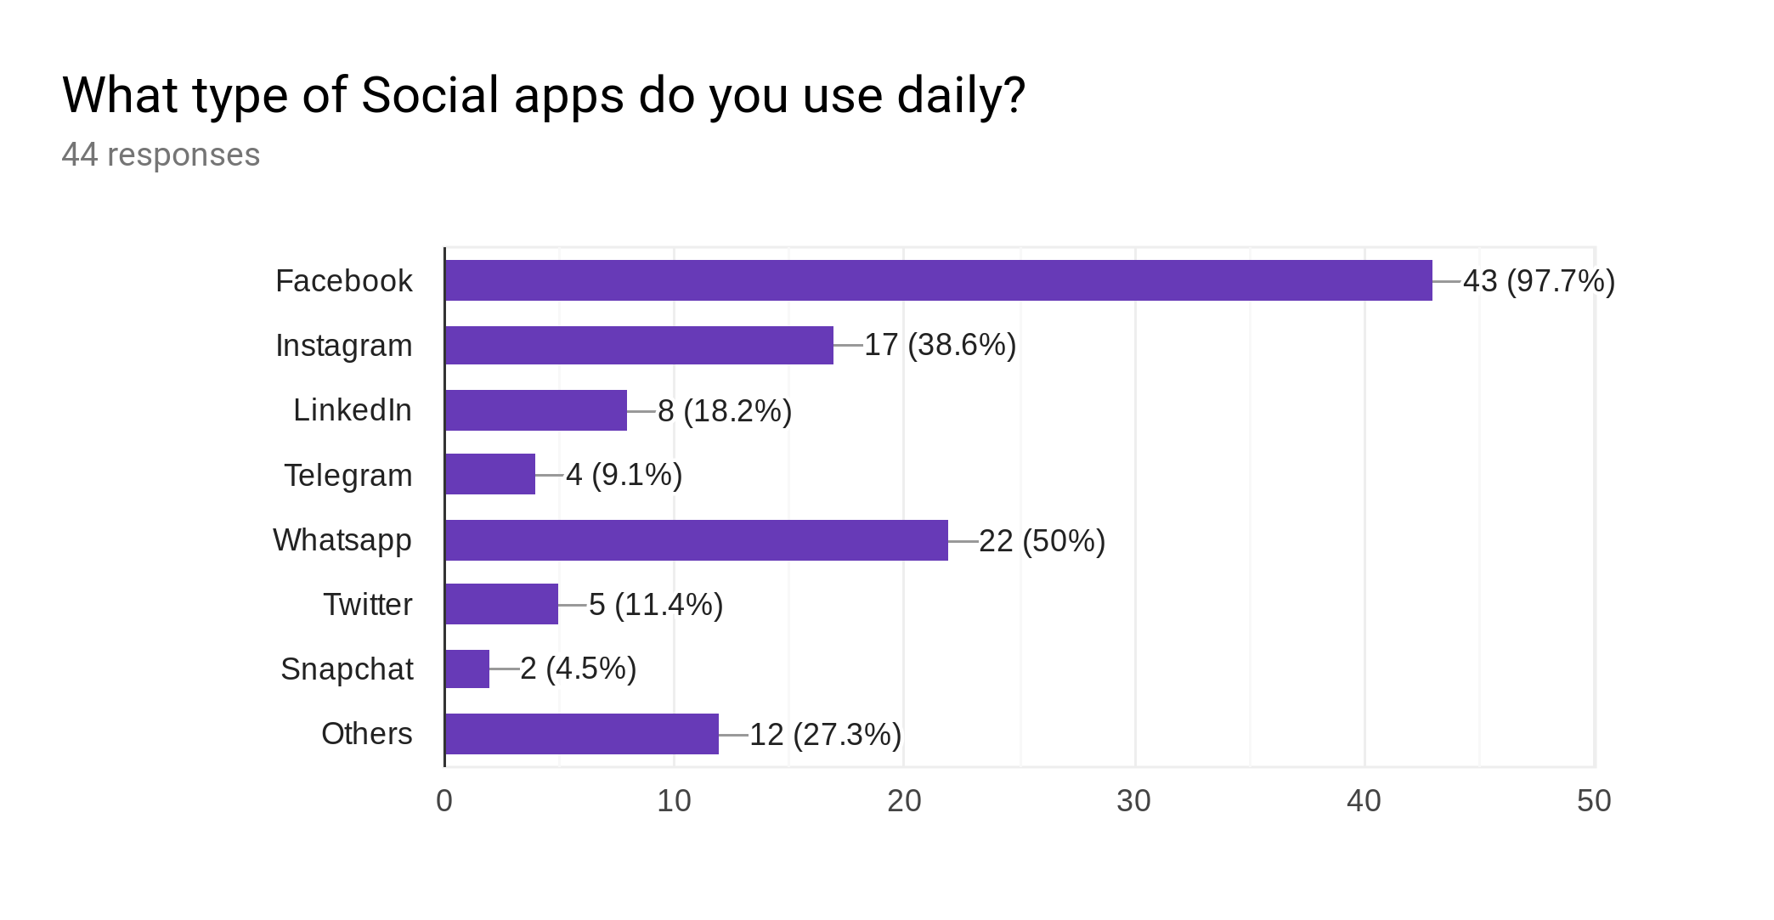

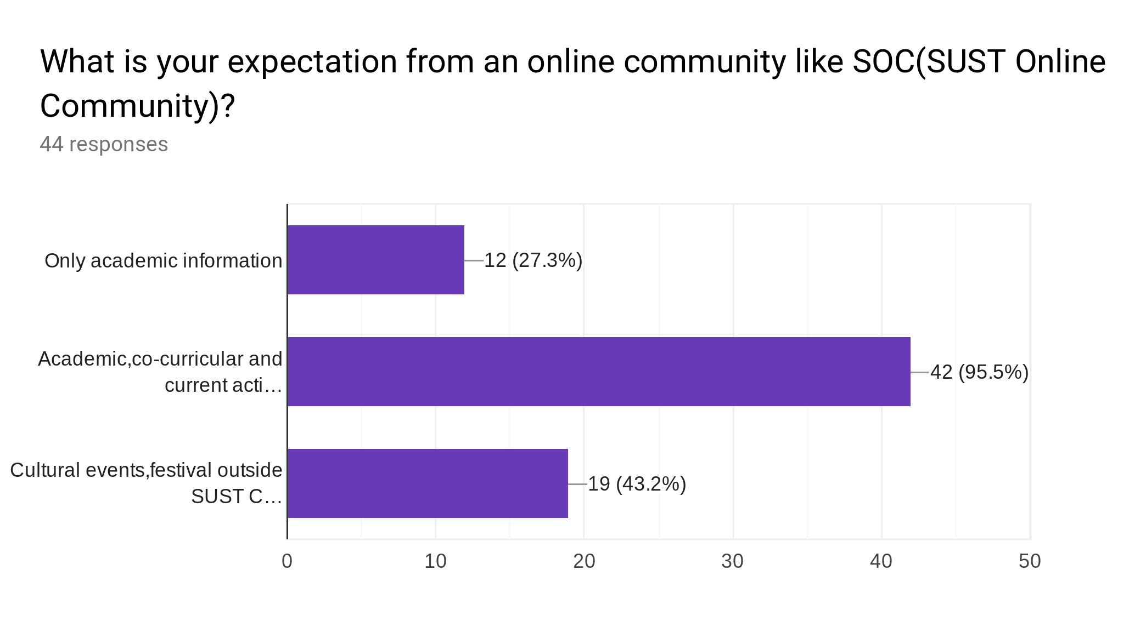

Figure : 3.0.2 Expectation for an online Community

## 3.1 User Interface :

* **Log In:** Login page is the first page of this system.User needs to give his email account and password to log inside the system.A new user will select the create account option to create an account of the system.
* **Newsfeed:** Newsfeed is the homepage of the system after logging in.It will be automatically generated based on most recent post.User can filter his newsfeed as he wants.
* **Profile:** An user can update his profile as he wanted.He can also see his shared post, response of his shared post, todo list.
* **Search Bar:** User can search any profile , department , organization etc by typing the content he is looking for.
* **Toolbar:**
  + **Info:** Here an user can see profile of other students, alumni, teachers , blood donors and also of the organization of SUST.
  + **Academics:** It’s a key part of SOC.Blog,Class update , Exam schedule, Tutorials, Resources, Notes, Exam Questions will be available in this option.
  + **Notifications:** An user will be notified recent activities, emergency post, Class Update, Departmental Tagged post, Achievements , Contests.
  + **Current Activities:** Here buzz words, recent contest , carnival, Festivals, cultural activities,religious affairs, reception and special events will be shown to a user.
  + **Other:** 
    - **Blood Bank:** An user can see blood donors here.

He can request a donor to donating blood in need

or he can post for emergency if needed.

* **Blog Entry:** An user can create a blog here.

Or write or post something in a existing blog.

* **Lost and Found:** If an user has lost something or found something he can post here.
* **Buy And Sell:** Here an user can sell his used product to them who are interested to buy it.
* **Photo Archive:** Photo archive is collection of photos posted by users.Mainly it’s an option to represent beautiful campus of SUST.

## 3.2 Hardware Interface:

To browse all pages require a browser with proper internet connection.

## 3.3 Software Interface :

* Teachers and students database store all information in

table formation.

* .Net framework will serve the information more precisely in a manner structure.
* Docker operating system will handle the client-server

structure.

* Windows operating system will serve the best user friendly interface.

## 3.4 Communication Interface :

This system will use HTML5 with common functionality, so that application will support in all web browsers.

# 4.System Features

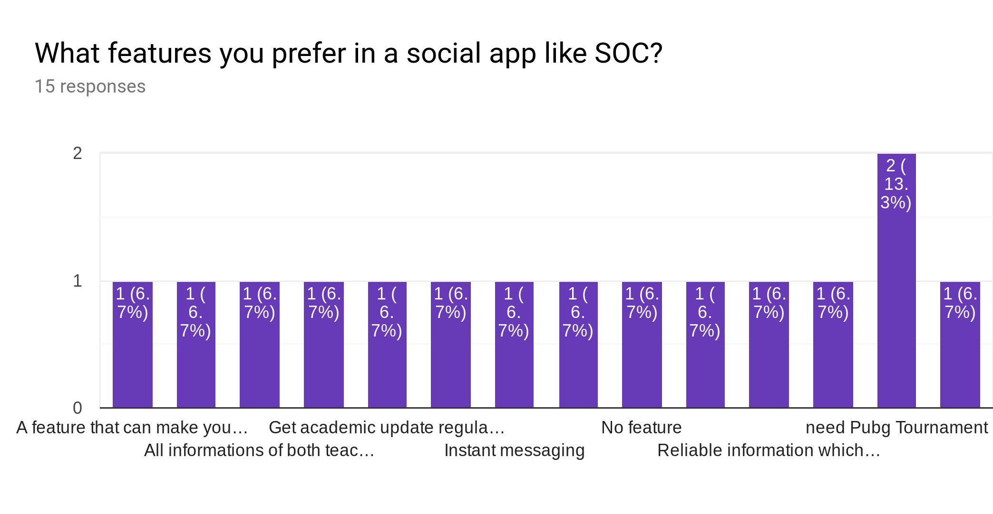

### Figure (4.1.1) : Feature Requirements

**Required Features:**

* All informations of both teachers and students.
* Get Academic update regularly.
* Instant messaging.
* Reliable Information.
* Important events like concern happening.

### Figure (4.1.2) : Activity Diagram of Login & Create Acc.

**Dashboard For Students**

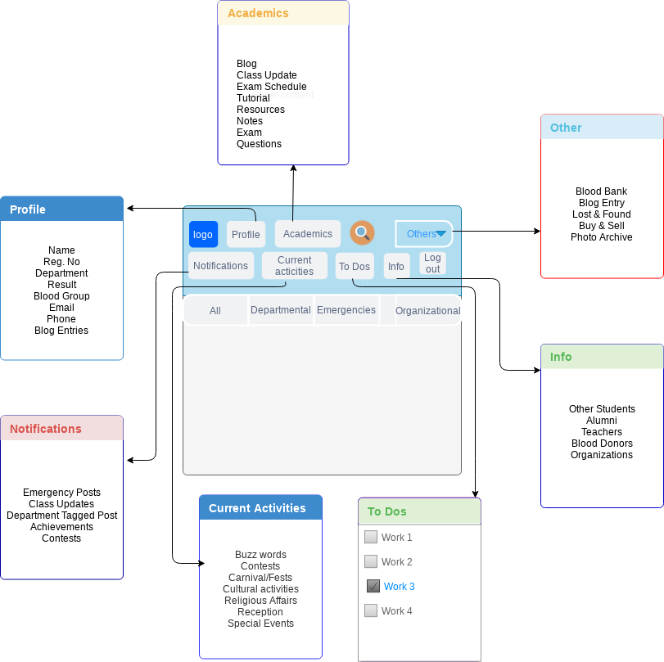

### Figure (4.1.3) : ER Diagram of student & system

### Figure (4.1.4) : ER Diagram of CR and System

**Dashboard For Teacher** 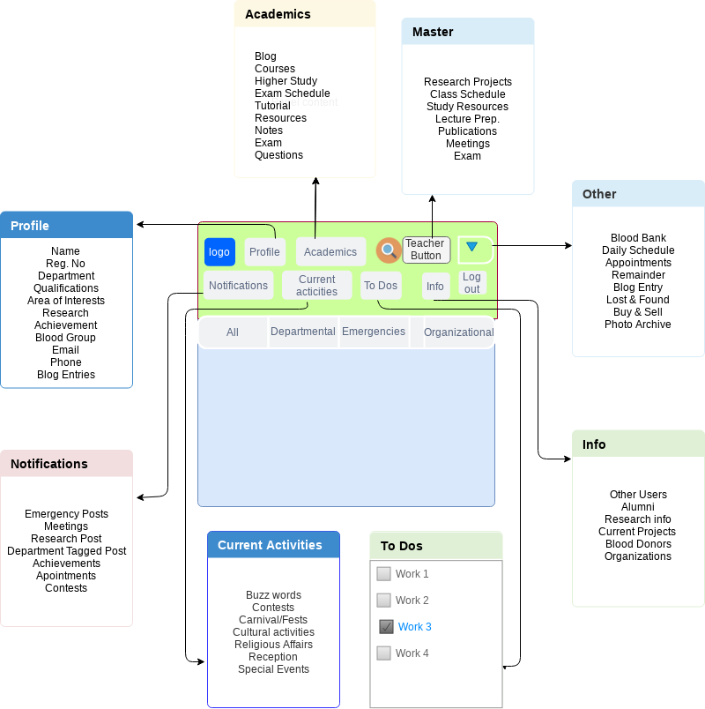

### Figure (4.1.5) : ER Diagram Teacher & System

### Figure (4.1.6) : ER Diagram Alumni & System

# 

# 

# 

# 

# 

# 

# 

### Figure (4.1.7) : Activity Diagram of Posting

# 

# 

### Figure (4.1.8) : Use Case Diagram.

### 5.Other Nonfunctional Requirements

## 5.1 Performance Requirements

Serve all the needed information correctly.

## 5.2 Safety Requirements

If there is extensive damage to a wide portion of the database due to catastrophic failure, such as a disk crash, the recovery method restores a past copy of the database that was backed up to archival storage (typically tape) and reconstructs a more current state by reapplying or redoing the operations of committed transactions from the backed up log, up to the time of failure.

## 5.3 Security Requirements

Security systems need database storage just like many other applications. However, the special requirements of the security market mean that vendors must choose their database partner carefully.

## 5.4 Software Quality Attributes

* AVAILABILITY: The systems should be available all time.
* CORRECTNESS: The systems should reach start from correct start terminal and should reach the correct destination.
* MAINTAINABILITY: The administrators and database of chargers should maintain correct schedules of connection.
* USABILITY: It should provide a usable interface for every class of user.